Dear Resident

Proposed closure of Talbot Road in front of the Tabernacle and Powis Square Gardens

We would like your views on a proposal to close a small section of Talbot Road between the Tabernacle and Powis Square Gardens to all traffic except for emergency vehicles, cyclists and pedestrians.

Please read the following information carefully before sending us your comments no later than 3 December 2021.

Background and Proposed Closure

A resident led steering group has been established to work in partnership with the Council on improvements to Powis Square Gardens. Initial discussions with the steering group have identified improvements to the gardens and the disconnection with the Tabernacle.

To address road safety concerns and to better connect the Tabernacle with Powis Square Gardens it is proposed that the small part of Talbot Road between the Tabernacle and Powis Square Gardens is closed to traffic, expect for cyclists and pedestrians. Emergency vehicle access would be maintained.

The proposed road closure would involve implementing an experimental Traffic Order which would allow the road to be closed for up to 18 months and during this time another consultation will take place in order to assess if this pilot should become permanent. If successful a permanent redesign of the road closure would be undertaken. This would involve public realm improvements which could be in the form of pavement widening, dropped kerbs, tree pits and permanent planters. These permanent improvements would be consulted on and co-designed with the local community.

An initial consultation was carried out on this proposal in 2020 but unfortunately the response rate did not meet our minimum threshold.

We are therefore contacting residents and businesses again to confirm whether they wish the Council to close Talbot Road between the Tabernacle and Powis Square Gardens.

Possible changes and the implications

If the proposal were to go ahead, it would mean that motor traffic would no longer be permitted to enter this section of Talbot Road and would remove three parking spaces. We would erect new signs to indicate this and would place planters to close the road, which would be located on the carriageway, but would still allow safe access for emergency vehicles, cyclists and pedestrians as normal. Talbot Road is part of a well-used local cycle route.

The planters would be placed at either end of the closed section of road as indicated in the attached plan. Additional measures including “Look Both Ways” signs and colourful road crossing to encourage safe crossing would also be installed.

The proposed road closure would result in the loss of three resident parking spaces indicated in blue on the attached plan.

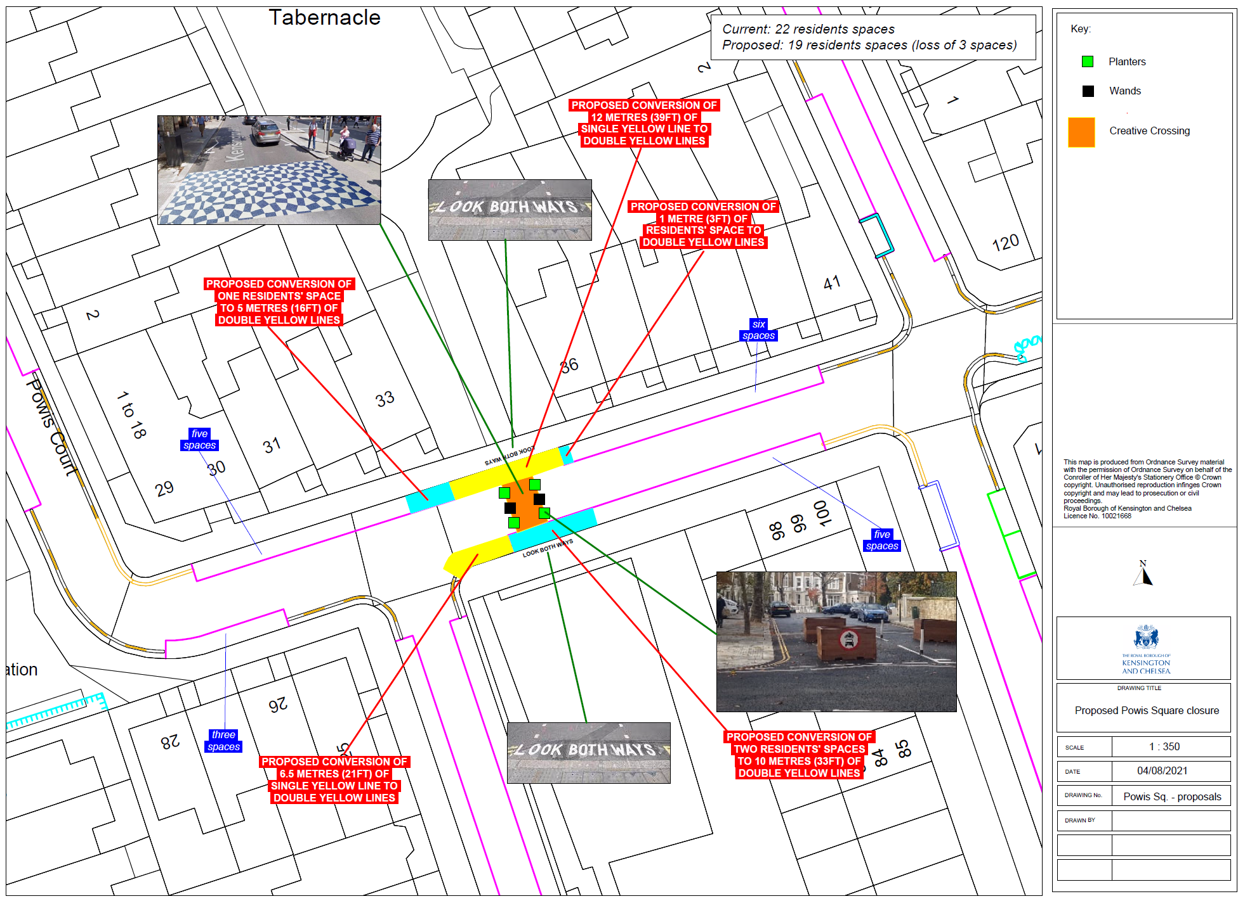

What happens next?

A full report of the results of the consultation will be presented to the Director for Streets and Regulatory Services who will then make a published decision, based on the views of local people, on whether or not the proposal should go ahead on an experimental basis.

If it were decided to go ahead with the closure, the Council would use an experimental traffic order to implement the road closure for a period of up to eighteen months. There would be opportunities to make formal representations on the order during the first six months.

Have your say

This is a chance for you to have your say on the proposal to close part of Talbot Road in front of the Tabernacle to all traffic except for cyclists, pedestrians and emergency vehicles.

Officers will only recommend that the closure of part of Talbot Road should proceed if at least ten percent of consultees in the consultation zone respond to the consultation, and at least fifty percent responses, including 50% of those consultees living on Talbot Road, support the proposal, so please respond to this consultation if you support or object to this proposal.

Please email your response to Powis@rbkc.gov.uk and provide the following information:

- Your name and address
- Whether you are a resident, or a business
- Whether or not you support the closure of part of Talbot Road

Please also add any additional comments you may have on the proposal.

Please email your response to us no later than 3 December 2021.

If you have any queries or require any further information please contact Alice O’Mahony.

Yours faithfully
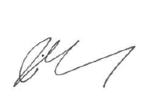
Alice O’Mahony
Senior Project Manager

